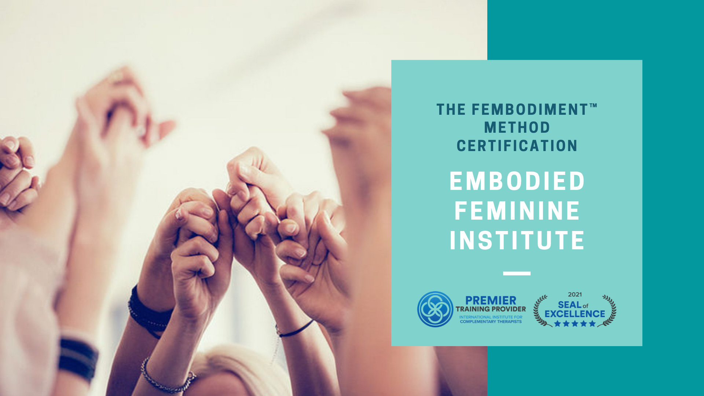

Embodied Feminine Institute Scholarship Exchange Program

Our intention behind the EFI Scholarship Exchange Program is to remove the financial barrier for those that might otherwise be held back from Fembodiment™ Method Level-1 Certification and to make this offering available to everyone who feels called to work towards their Fembodiment™ transformation. In exchange for your skills, we are offering financial support through two scholarships:

- Full Support Scholarship: one successful applicant will be awarded a 100% of tuition costs.

- Partial Support Scholarship: one successful applicant will be awarded a 50% of tuition costs.

All sections need to be completed.

Full Name, Pronouns, (optional) & Ethnicity (optional).

Email address

Please list your average yearly income

Please describe your financial situation and why you would like to receive this scholarship

Have you read fully through the details of the Fembodiment™ Method Level-1 Certification?
https://www.embodiedfeminineinstitute.com/facilitator-training-level-1

Yes

No

Please tell us about your embodiment journey.

Can you commit to finishing the training in One Year and to the additional hours (14-20 per week) required outside of the online classes to complete the practices and participated in the forum?

Yes

No

How will you use these Fembodiment™ practices and processes in your personal life and and how will you give back to the EFI Collective?

What other skills could you offer EFI Collective in exchange for your scholarship? (For example some ideas include – skills in marketing, community work, writing, photography, video, social posting etc).

Would you be willing to create 2-3 written and/or video testimonials throughout the training?

